**Atlantic Grains Council Research**

**2022 On Farm Research Summary**

**Barley Nitrogen Timing Trial**

The objective of the trial was to determine if there is a yield benefit from applying controlled release nitrogen (ESN or PurYield), using nitrification inhibitors (non-leaching Agrotain coating) or splitting nitrogen applications. The trial has been conducted since 2019 with 30 sites in Nova Scotia, New Brunswick and Prince Edward Island.

The following graphs highlight the results from the past growing season (Figure 2) and overall results for the past four years (Figure 3).

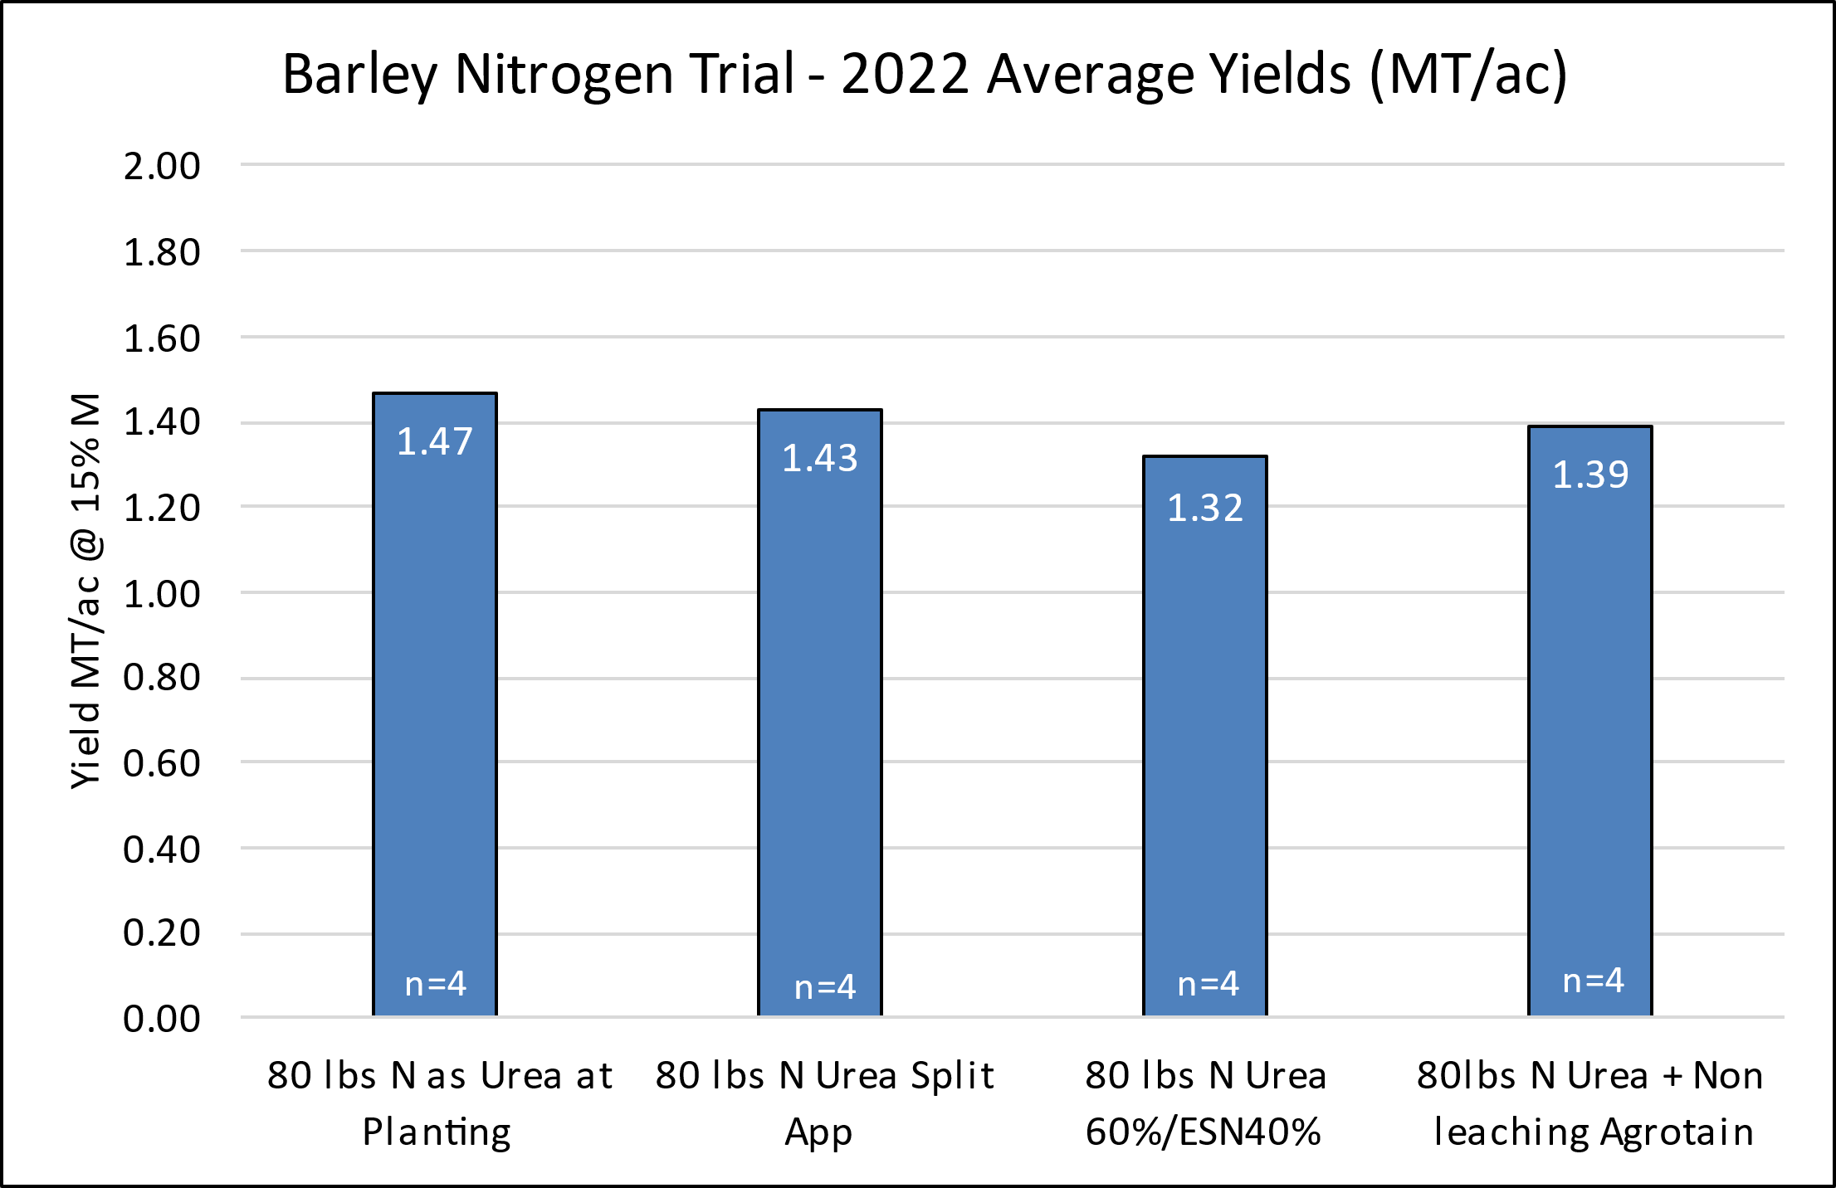

Figure : Yield responses to the four treatments across the Maritimes in 2022.

The 2022 yields were highest in the 80 lb/ac at planting followed by the split application. The ESN/Urea mix had the lowest yield.

The effectiveness of the products is heavily dependant on the weather during the first few months of the growing season when the fertilizer is applied. The amount of moisture and temperature of the soil affects nitrification and nitrogen losses.

Figure 3 show the results over the past four years, in which there is no statistical difference in yield between treatments.

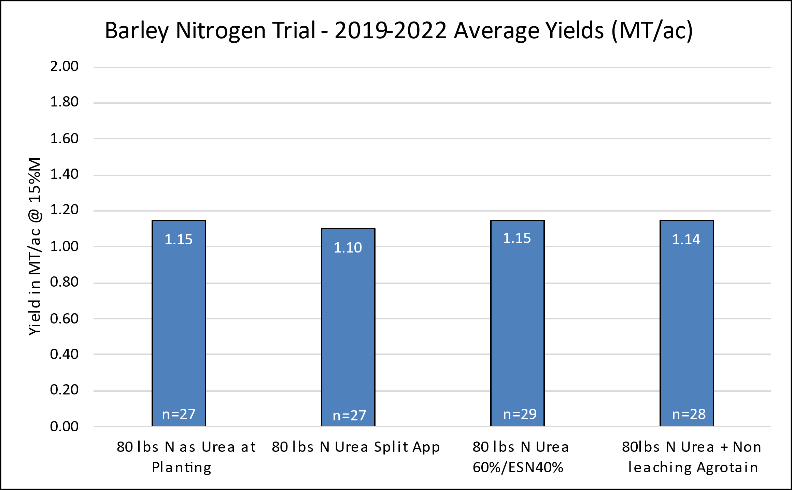

Figure : Yield responses to the four treatments on all sites in the Maritimes over four years.

There is a cost difference between treatments, for the extra fertilizer pass over the field and the additional cost of the nitrogen products above that of urea. Because there was no increase in yield using the products or splitting the nitrogen application, there is a negative economic return to the producer.

Figure 4 shows the added cost per acre for the treatments with the crop value per acre based on yields. The crop value of barley in 2022 was approximately $350 per metric tonne.



Figure 4: Loss on Investment by treatment based on 2022 fertilizer and crop prices

Using these products may have a positive environmental impact, however they result in a loss of profit to producers.

The OFCAF (On Farm Climate Action Fund) funding is currently offering a one time per field incentive for using some protected nitrogen products (paying a portion of the difference between standard nitrogen fertilizer and the protected nitrogen products). Producers should not be responsible to shoulder the financial burden of protecting the environment and society should contribute to these additional costs, especially if producers are required to use these various treatments in the future.

Further study is needed to show the environmental impact of using the products. The trial will be adapted in 2023 to study the green house gas emissions between urea and the non-leaching agrotain (DCD). This will encourage producers to adopt practices which reduce nitrogen losses and inform government for funding policies.