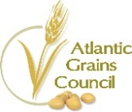
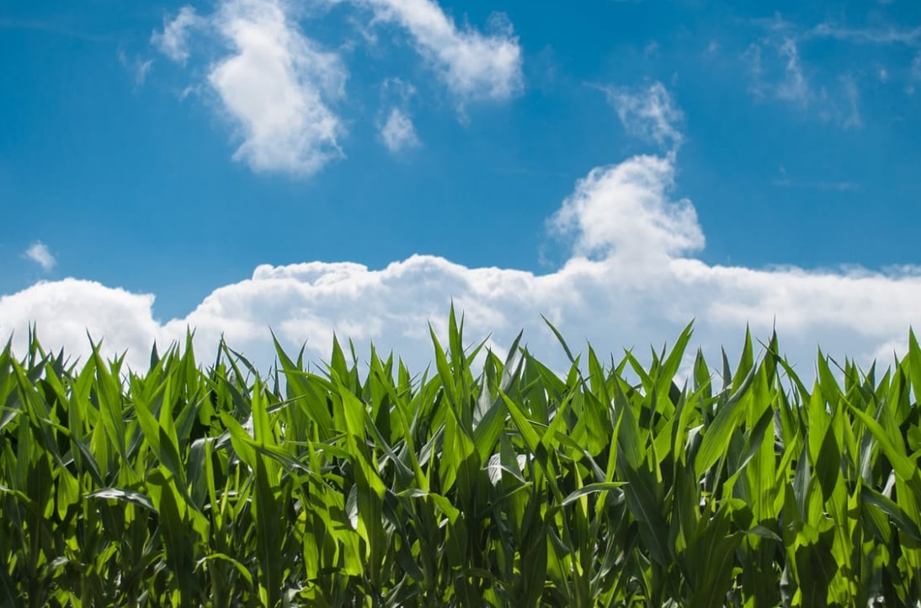
CORN
CANADA 2019
- 13,403,900 MT (Grain)
- $2,747,799,500 (Total)
- 3,585,700 acres (Grain)
- 864,100 acres (Silage)
ATLANTIC CANADA 2019
- 115,500 MT (Grain)
  - 26,000 MT (NB)
  - 49,500 MT (NS)
  - 40,000 MT (PE)
- $23,677,500 (Grain)
  - $ 5,330,000 (NB)
  - $10,147,500 (NS)
  - $ 8,200,000 (PE)
- 38,100 acres (Grain)
  - 9,100 (NB)
  - 17,000 (NS)
  - 12,000 (PE)

Corn is a popular crop in Canada with 3.6 million acres devoted to gain production with an addition 0.9 million acres used for silage in 2019. Grain corn, by tonnage, is the second largest cereal crop grown in Canada, with 13.4 million tonnes produced in 2019.
In Atlantic Canada, a total of 71,000 acres were seeded to corn in 2018, representing approximately 22% of the area seeded to cereals and oilseeds in the region. The 38,100 acres devoted to grain production produced 115,500 tonnes and the 36,200 acres in silage provided an estimated 423,000 tonnes of silage. Nova Scotia is the leading corn producing province in the region.
In 2019 grain corn resulted in an estimated on-farm value of $2.7 billion, representing 9% of total grain receipts in Canada. In Atlantic Canada the $23.7 million value of grain corn makes it the regions most valuable cereal crop.
ATLANTIC GRAINS COUNCIL
381 Killam Drive
Moncton, NB E1C 3T1
T (506) 381 5404
C (506) 380 9663

www.atlanticgrainscouncil.ca
Currently, the Atlantic Grains Council is conducting on-farm trials on the impact of boron and sulphur on yield. Results will be published on the website as they become available.

Area, Yield, Production of Canadian Principal Field Crops – Agriculture and Agri-Food Canada, Agricultural Industry Market Information System and Estimated areas, yield, production, average farm price and total value of principal field crops – Statistics Canada
Canada: Grains and Oilseeds Supply and Disposition -– Agriculture and Agri-Food Canada, Agricultural Industry Market Information System.

